
All applications forms must be sent to:
1-7 Langleys Road
Selly Oak, West Midlands, B29 6HR, United Kingdom
Tel: 01384 671511
Mob: 07510700745 On-call: 07510700745
Email: info@balmcareservices.com

APPLICATION FORM

We cover the West Midlands

We have very competitive pay rates
Please complete this form in black ink and complete all sections
Position Applied For
Your name

Which part of the UK do you live in?
Do You Drive?
Data Protection Statement
The personal information (data) collected on this form, and on the attachments, (which includes the collection of sensitive personal data) are collected for the purposes of recruitment, personnel administration (for new employees)
and monitoring. Unless you direct otherwise (for example in a situation where you would like this Application kept on file for future vacancies) the Application Forms (and attachments) of unsuccessful applicants will be destroyed after 6 months. It is the policy of the Agency to protect, and keep secure, all personal data collected. All personal data is processed for the purposes of recruitment, and, in the case of successful Applicants, for the satisfactory administration of their employment, and for no other purpose.
Equality of Opportunity Statement
The Agency’s Equal Opportunities Policy covers all employees, or potential employees, and embraces the principle that all people shall be treated equally, regardless of their age, gender, ethnic origin, nationality, colour, religion, marital status, sexual orientation, religion or belief, disability, or offending background.
Which of the following applies to you?
Support worker Please  as appropriate |  | HCA |  | Other:
Full Time

Part Time
1

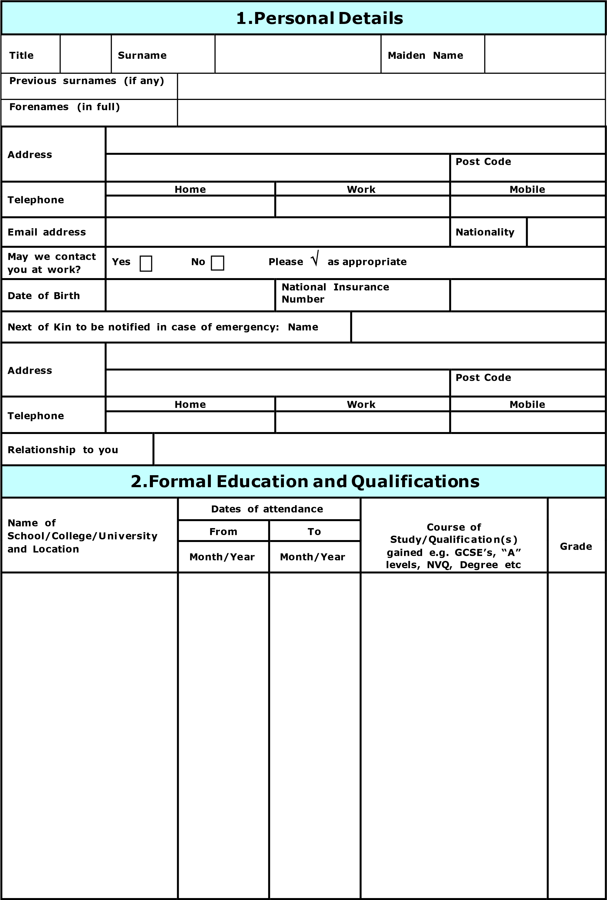
3.Employment History
Please print details of all your employment for a period of at least the last 5 years, to current, continue on a separate piece of paper if not fitting.
Name & address of  Employer | Dates of Employment |  | Position held and brief summary of duties and responsibilities | Reason for leaving/Last salary or wage
Name & address of  Employer | From | To |  | Reason for leaving/Last salary or wage
Name & address of  Employer | Month/Year | Month/Year |  | Reason for leaving/Last salary or wage
4. Training – _{eg.} Manual handling, CPR, infection control, first aid
Details of training  Hospital/establishment | Date from Date to |  | Courses taken | Attainment

5.HEALTH RECORDS
All applicants are required to make a statement with regards to their physical and mental fitness. Please answer all the questions listed below and provide details for the relevant answers:
Are you suffering , or have you ever suffered from any of the following | Yes | No
a) Back or neck pain?
b) Rheumatic or arthritic conditions?
c) Hernia?
d) Upper limb disorder such as tenosynovitis, tendonitis or carpal tunnel syndrome?
e) Fits, fainting attacks, epilepsy?
f) Depression, anxiety or nervous illness?
g) Typhoid, paratyphoid, dysentery or food poisoning?
h) Tuberculosis or hepatitis?
Any illness or medical condition not specified above? If so give details on separate sheet.
Have you undergone psychiatric treatment of any kind in the last five years?
Are you currently undergoing any treatment, medical /psychiatric?
Are you pregnant or been pregnant within the past 3 months?
If Yes, Please confirm if you are medically fit to work
Have you taken significant time off work for medical reasons over the last 12 months?
If Yes, how long did you take off?
If you answered “Yes” to any of the above questions, please provide details on a separate sheet.
Health Statement: Please use the space below to make a statement as to whether or not you consider yourself physically and mentally fit for the position for which you have applied.

I can confirm on (today’s date ) .........................................................../ .........................................................../ ........................................................... that I am not
(Delete as appropriate ) physically, mentally and emotionally fit for the position I have applied for, as detailed in the job description provided by Balm care services ltd.

Signed: ..................................................... Date: .................................

6. References
References are normally taken up for candidates selected for interview. Give details of the names/addresses of two work-related Referees. One of the Referees should be your current employer, or if presently unemployed or self-employed, your last employer
Name, Address and Email |  | Name, Address and Email
Telephone Number |  | Telephone Number
Position |  | Position
Relationship to you |  | Relationship to you
May we contact the above person now?  Yes No Please  as appropriate |  | May we contact the above person now?  Yes Please  as appropriate  No

7. Confidentiality Declaration

Registration implies acceptance of our code of confidentiality.
In the course of your duties you may have access to confidential information about your clients. On no account must information relating to identifiable client be divulged to anyone other than the manager of the agency. You should not disclose ANY information to your family, friends or neighbours.
If you are worried by any information you have obtained and consider that you should talk about it to someone else MAKE AN APPOINTMENT TO SPEAK IN PRIVATE TO YOUR MANAGER.
Failure to observe these rules will be regarded as serious misconduct which could result in removal from the agency register.
I have read and I understand the above and I agree to abide by the contents therein.

Signed Date

8.Rehabilitation of Offenders Act
As a general rule, no-one need answer questions about spent convictions. However this general rule does not apply to specified professions, employments and occupations. By virtue of the Rehabilitation of Offenders Act 1974 (Exceptions) (Amendment) Orders, the exemption rule does not apply to:

- any employment or other work which is concerned with the provision of health services and which is of such a kind as to enable the holder of that employment or the person engaged in that work to have access to persons in receipt of such services in the course of his normal duties, or
- any employment or other work which is concerned with the provision of care services to vulnerable adults and which is of such a kind as to enable the holder of that employment or the person engaged in that work to have access to vulnerable adults in receipt of such services in the course of his normal duties

One or both of the above apply to work with the Agency, and covers all occupations.

You are therefore requested to provide details of all convictions, including those which would otherwise be considered as “spent”. All employment applications will be considered carefully, and the disclosure of a conviction does not imply that this employment application will be rejected.

Records will be checked via the Criminal Records Bureau
procedures I have no convictions I have convictions (see
Note below)
Please  as appropriate
Note
(To protect the confidentiality of this information, please detail convictions on a separate sheet of paper. Place it in a sealed envelope with your name clearly visible, and headed “Private and Confidential – Criminal Convictions” and
attach this to your completed Application Form)
Criminal Records – Disclosure Certificate
The Criminal Records Bureau (CRB) have issued a Code of Practice regarding Disclosure Information, a copy of which is available upon request. A Disclosure Certificate (standard or enhanced) will be requested from the CRB which will detail all convictions, including those which would otherwise be “spent”, as well as details of cautions, reprimands or final warnings. You will be advised of the type of certificate being requested, and asked to give your approval to this application. The Disclosure Certificate will only be requested in the event that you are successful in your application for employment.
Asylum and Immigration Act 1996
Under Section 8 of the Asylum and Immigration Act 1996 it is a criminal offence to employ a person aged 16 or over who is subject to immigration control unless:

- That person has current and valid permission to be in the United Kingdom and that permission does not prevent him or her from taking the job in question; or

- The person comes into a category specified by the Home Secretary where such employment is allowed

Any employment offered will be subject to the successful applicant producing appropriate evidence that the Asylum and Immigration Act is not being contravened.

Are you eligible to work in the UK? Yes No Please  as appropriate
Personal Declaration
I declare that to the best of my knowledge the above information, and that submitted in any accompanying documents, is correct, and

- I give permission for any enquiries that need to be made to confirm such matters as qualifications experience and dates of employment, and for the release by other people or organisations of such information as may be necessary for that purpose.
- I give permission for the processing of the personal data contained in this form for employment purposes
- I understand that any false or misleading information could result in my dismissal.

Signed Date

